How to connect to create sql database

1. Go to search
2. Search sql database
3. Create database
4. Give resource group
5. Database name
6. Now go to server
7. Create server using name

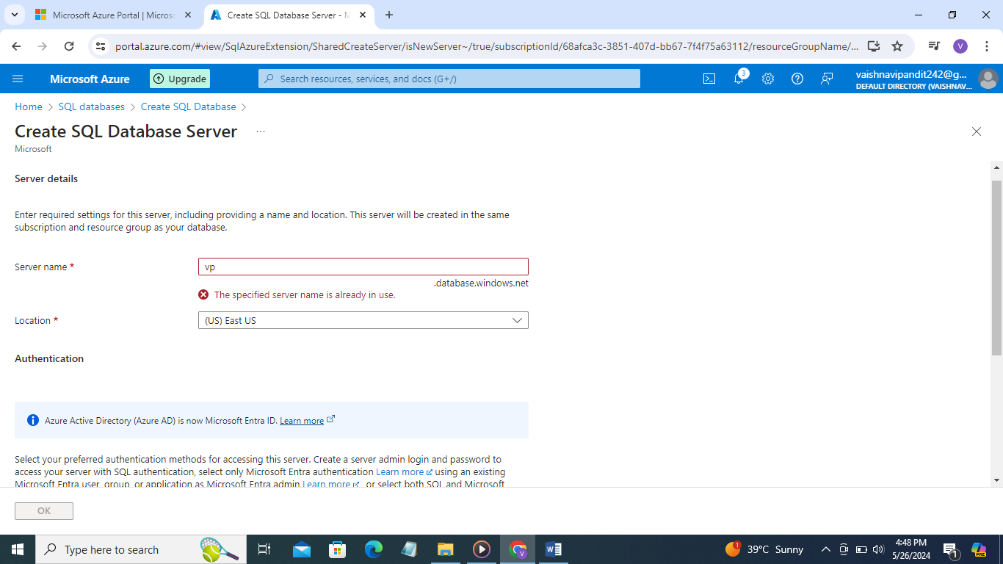

1. Go to authentication go to use sql authentication give login id password.

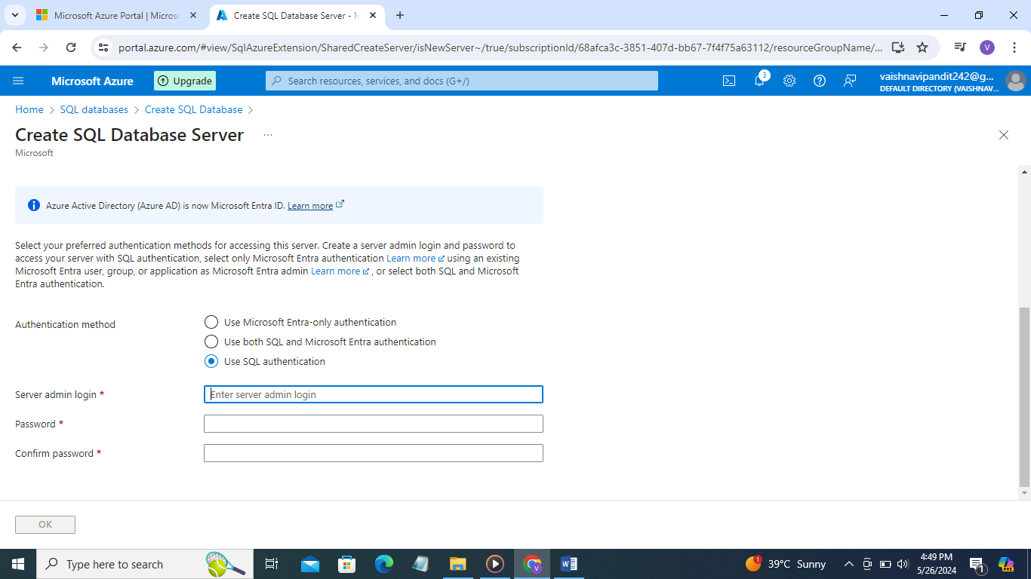

1. Now go to compute+storage

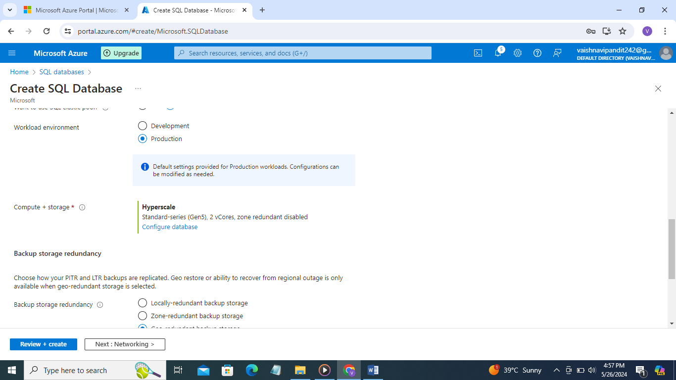

1. Select basic service tier

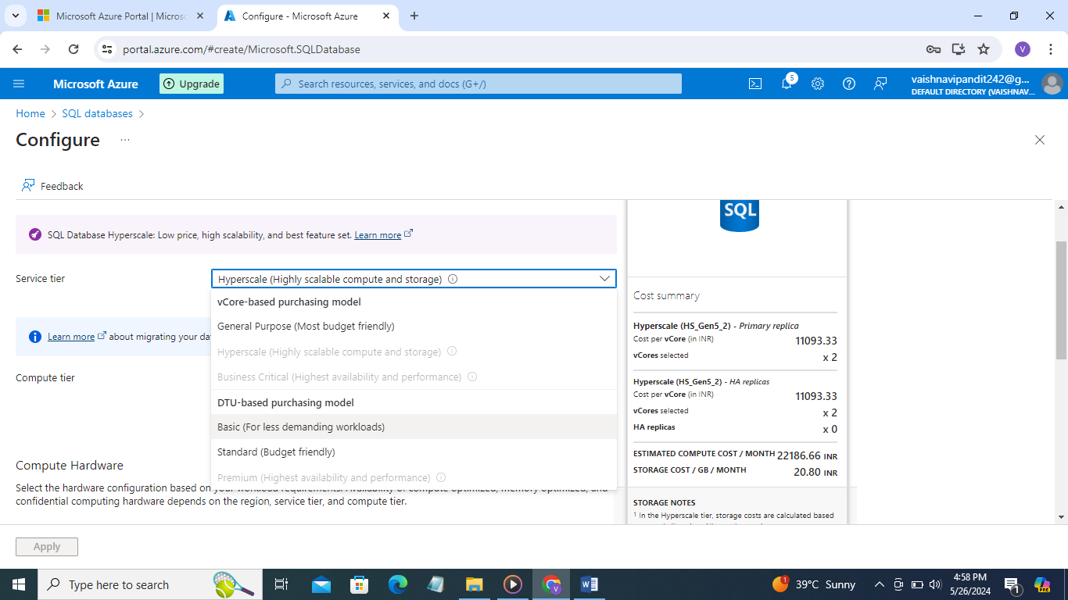

1. Do max data 0gb
2. Apply
3. Review+create

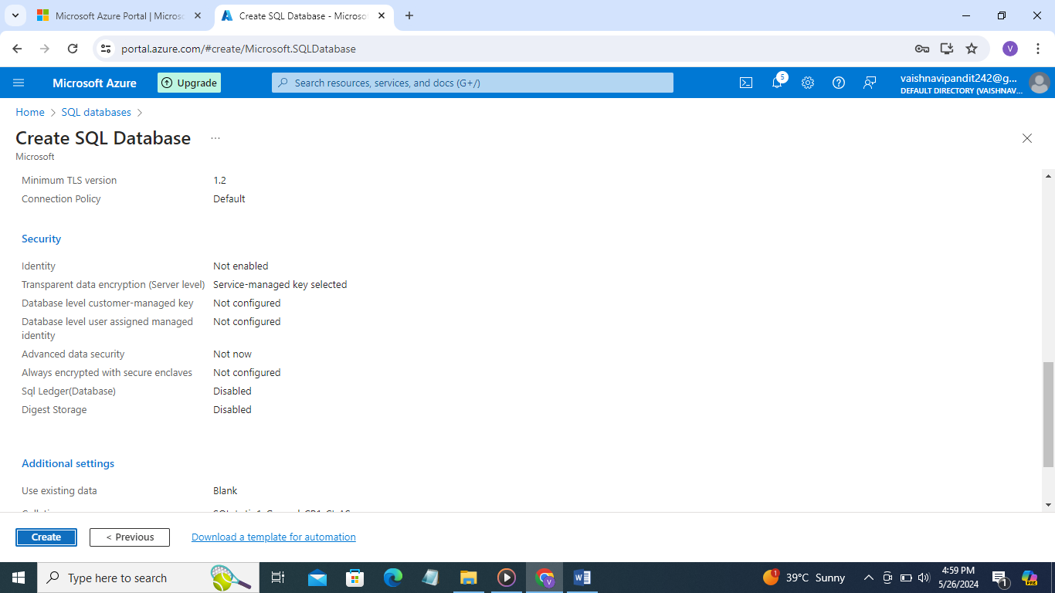

1. Now database and server will be created